Little SPARK: Simple Play Adaptations to Reference for Kids

QuickTalker FeatherTouch 12
Description: | Image:
The QuickTalker FeatherTouch 12 is a multi-celled, multi-leveled message static display augmentative and alternative communication (AAC) speech device that can assist children who need speech support throughout their daily activities. | 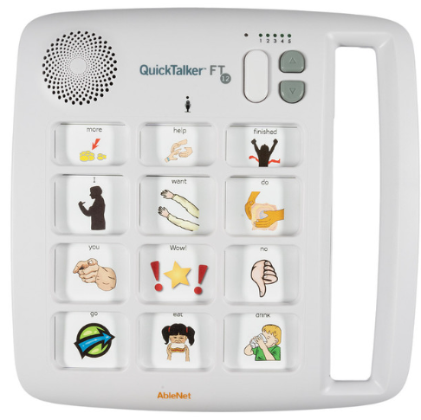

Who Might Benefit?
Those who are difficult to understand and express communication, experience frustration and social difficulties due to unclear speech and challenges with following oral or multi‑step directions yet demonstrate the fine motor skills needed to access a communication device.
Why Use?
Provides an opportunity to make choices, comment to others, view a visual and auditory cue as many times as needed to support schedules, routines, activities, and instruction.
Instructions for Use: | Adaptation Ideas:
Environmental Considerations  - Use in any environment and on the go, avoid using in unusually loud spaces.  Positioning & Alternate Positioning  - Use in any position or attach to any surface.  Basic Play/Use  - Place a picture symbol in the frame, record, and press play using the front button.  Extended Play/Use  - Use for any of the following: instruction, requests, participation, information sharing, communication, games, classroom management, or self-care skills. | Build It Up  - Velcro a plastic bottle cap to the button to build up the surface.  Simplify It  - Introduce the levels gradually or consider using fewer cells.  Stabilize It  - Velcro to most surfaces or place Dycem/cabinet liner under the switch.  Add Sensory Cues  - Add textures or change the button color.  Alternative Uses  - One of the device’s five levels can be used for rotating classroom content (such as weekly themes, calendar responses, counting, or storybooks).  - Serve as a shared classroom tool for peers or adults to support center activities, provide step‑by‑step directions, build vocabulary, and model AAC use.

